**References**

1.Parental Involvement in Education https://bit.ly/3atz5pI



2. Effective Learning Strategies used in Mastery Learning Folders

https://bit.ly/2Rj9591



*“Using the Mastery Learning Folders has been a positive experience for all involved. The process is quick and easy to use. I've seen a magnificent improvement in the students' sight words, reading and writing. It has been awesome."*

*Jocelyn, Year 1 Teacher*

*"We did the big test on the girls' words today and they both got 100% for the first time. Happy days!!! Might try to do the tables as well because we are struggling with them. Thanks for creating such a great tool."*

*Leanne, Home-schooling Mum*

*The learning experience was very enjoyable. My daughter enjoyed moving the flashcards along in the folder and could see her progress. " Lorena, Parent*

*"I have been using the folder for spelling with a very reluctant learner in Year 3. He is not willing to have a go due to fear of failure. The Mastery Folder has been pivotal in addressing this - each time we move a word to the next pocket he sees success! "*

*Lawri, Teacher*

A Parent’s Guide to …

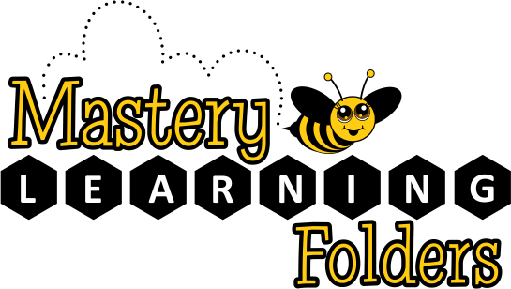

“Research on the effects of

parental involvement has shown

a consistent, positive relationship between parents' engagement in their children's education and student outcomes.” 1

The Mastery Learning Folder process is continually under review and your feedback is welcome.

Nicola Carr-White MEd

masterylearninggroup.com.au

admin@masterylearninggroup.com.au

**Important Points**

**Follow the Folder Instructions**

It might be tempting to want your child to always answer correctly, however, the increasing spaced intervals between flashcard testing is *designed* to create a remembering struggle. The goal is to create *effortful but successful* retrievals of the content to be learnt. However, if over time, your child experiences too much effort and not enough success, then add more folder sessions to the week which will make retrieval easier. Practice sessions should take less than 10 minutes.

**Foster Resilience**

When your child answers incorrectly, remind them that forgetting and struggling to remember are part of the learning process. When flashcard content returns to the same pocket, it just facilitates more learning time. Help your child to reflect on and value their progress.

**Understand Your Impact**

You have the opportunity to significantly impact your child’s education with small investments of time. A regular routine may help and other family members may be assist with the short folder sessions.

**Parent Support**

Please visit the Mastery Learning Group parent page to view the Parent Training Video:

https://bit.ly/33RMaL8

The goal of the folder process is to facilitate the struggle to remember which helps to move learning from working to long-term memory. Once learning is secure in long-term memory, working memory becomes available for higher order thinking and learning objectives.

Mastery Learning Folders enable your child to practise foundational learning content according to individual needs, through a partnership between educators, parent and student.

The regular practise of skills, such as mental math strategies and phonics, is essential to move learning from working memory to long-term memory.

Mastery Learning Folders use four of the six cognitive science learning strategies that have been identified as most effective in creating durable learning2:

* spaced practice
* retrieval practice
* elaboration and
* interleaved practice

Thank-you for being involved - this type of individualised practice is not possible without you!